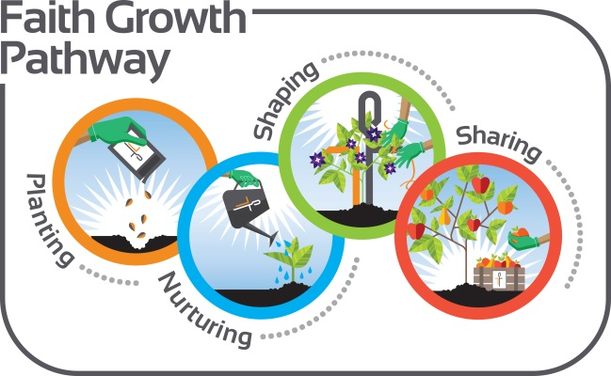
Faith Growth Pathway
Date: ______________________________

I feel confident in my Faith Journey in this area: __________________________________

I would like to grow in this/these area(s) in my Faith Journey: ______________________________________________________________________________
______________________________________________________________________________

Action Plans:

Next Meeting: _________________________________________
Rev. Kathy Pittenger
Pastor of Lifelong Faith Formation
kpittenger@waterfordcumc.org; 248.681.0040

